| **Test Name** | | | Submit new question | | | |
| --- | --- | --- | --- | --- | --- | --- |
| **Use Case Tested:** | | | Submit question | | | |
| **Test Description:** | | | Check that fields are editable | | | |
| **Pre-conditions** | | | User must of logged in  Submit question scene should be open | | | |
| **Post-conditions** | | | That all input fields can be edited | | | |
| **Notes:** | |  | | | | |
| **Result (Pass/Fail/Warning/Incomplete)** | | **Pass** | | | | |
|  | **TEST STEP** | | | **EXPECTED TEST RESULTS** | P | F |
|  | User writes in question field | | | Field should be editable | P |  |
|  | User writes in all answer fields | | | Fields should be editable | P |  |

|  |  |  |  |  |  |
| --- | --- | --- | --- | --- | --- |
| **Test Data Table** | | | | | |
|  | **1** | **2** | **3** | **4** | **5** |
| Which is the only film of the original six in which desert planet Tatooine doesn’t appear? | The Empire Strikes Back | Return of the Jedi | A New Hope | The Phantom Menace |  |
|  |  |  |  |  |  |

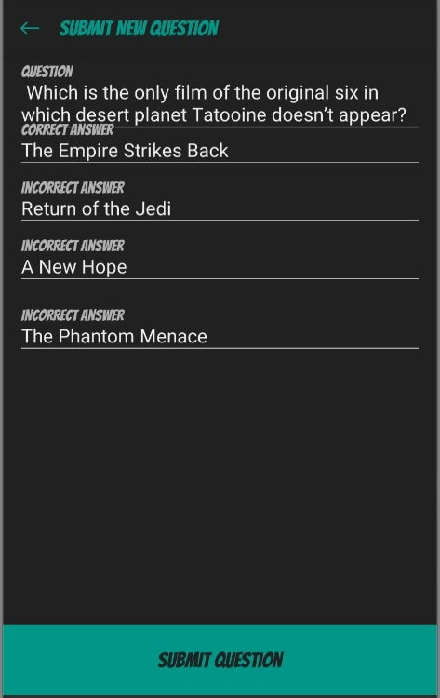

Submit question page with all input boxes filled

| **Test Name** | | | Submit new question | | | |
| --- | --- | --- | --- | --- | --- | --- |
| **Use Case Tested:** | | | Submit question | | | |
| **Test Description:** | | | Check that submit button adds new question to database | | | |
| **Pre-conditions** | | | User must of logged in  Submit question scene should be open | | | |
| **Post-conditions** | | | Question should be added to the question database | | | |
| **Notes:** | |  | | | | |
| **Result (Pass/Fail/Warning/Incomplete)** | | **Pass** | | | | |
|  | **TEST STEP** | | | **EXPECTED TEST RESULTS** | P | F |
| 1. | Enter question | | | Question will be entered | P |  |
| 2. | Enter four answers | | | Four answers will be entered | P |  |
| 3. | Hit submit question button | | | Details should be sent to server and added to the question pool/answer pool and message saying attempting to submit question should display | P |  |

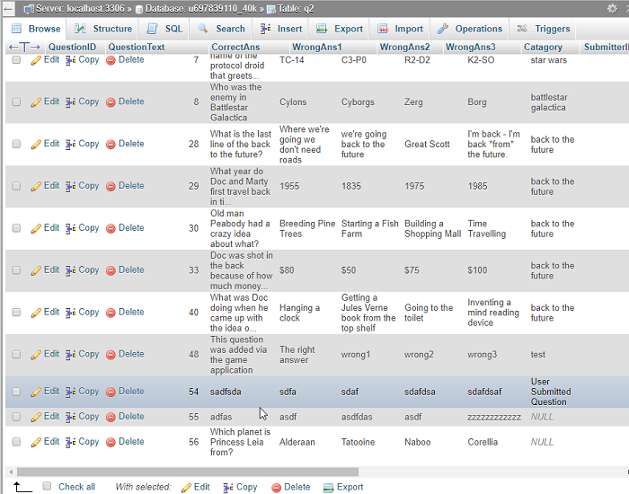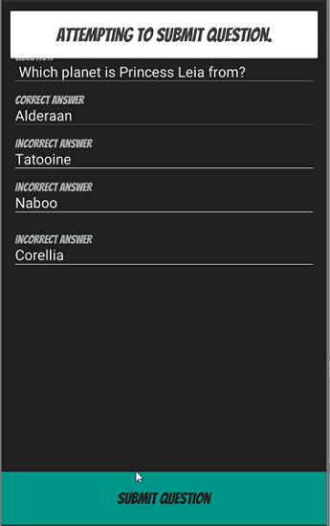

Question added to database QuestionId 56

Question input submit question pressed and correct message displayed

| **Test Name** | | | Submit new question | | | |
| --- | --- | --- | --- | --- | --- | --- |
| **Use Case Tested:** | | | Submit question | | | |
| **Test Description:** | | | Check to see that error message displays when question and answer fields are blank | | | |
| **Pre-conditions** | | | User must of logged in  Submit question scene should be open | | | |
| **Post-conditions** | | | Error message should be displayed | | | |
| **Notes:** | |  | | | | |
| **Result (Pass/Fail/Warning/Incomplete)** | | **Pass** | | | | |
|  | **TEST STEP** | | | **EXPECTED TEST RESULTS** | P | F |
| 1. | Leave question field blank while other fields filled in | | | Error message question cannot be empty is displayed | P |  |
| 2 | Leave correct answer blank while other fields filled in | | | Error message correct answer cannot be empty is displayed | P |  |
| 3 | Leave 1st wrong answer blank while other fields filled in | | | Error message wrong answer 1 cannot be empty is displayed | P |  |
| 4 | Leave 2nd wrong answer blank while other fields filled in | | | Error message wrong answer 2 cannot be empty is displayed | P |  |
| 5 | Leave 3rd wrong answer blank while other fields filled in | | | Error message wrong answer 3 cannot be empty is displayed | P |  |

|  |  |  |  |  |  |
| --- | --- | --- | --- | --- | --- |
| **Test Data Table** | | | | | |
|  | **1** | **2** | **3** | **4** | **5** |
| Question blank | empty | Which answer is correct | Which answer is correct | Which answer is correct | Which answer is correct |
| Correct answer | right | empty | right | right | right |
| Incorrect answer | wrong | wrong | empty | wrong | wrong |
| Incorrect answer | wrong | wrong | wrong | empty | wrong |
| Incorrect answer | wrong | wrong | wrong | wrong | empty |

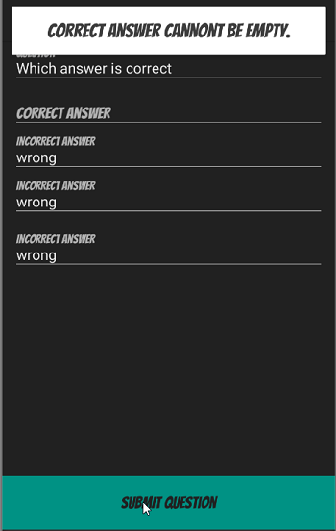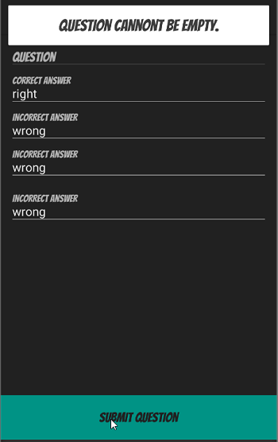

Question empty error displayed Correct answer blank error displayed

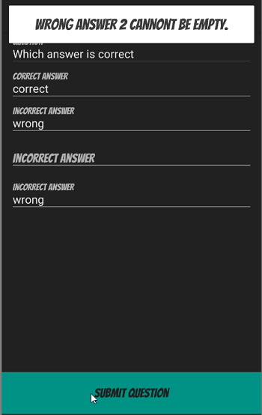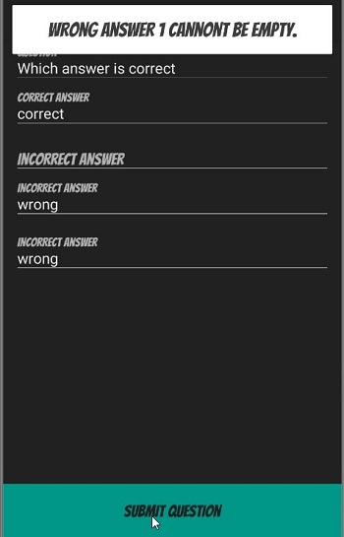

Wrong answer 1 blank error displayed Wrong answer 2 blank error displayed

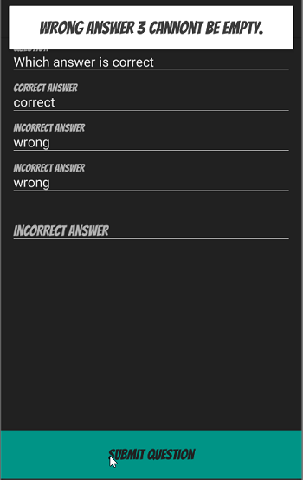

Wrong answer 3 blank error displayed